Objective Questions

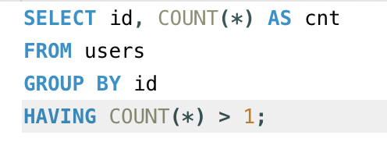
- Are there any tables with duplicate or missing null values? If so, how would you handle them?
Business Logic – Unclean data distorts platform engagement metrics, as meta gets most of its revenue from running Ads it would be waste of Cost-Per-Click
Query – To ensure there are no duplicate user id’s we use

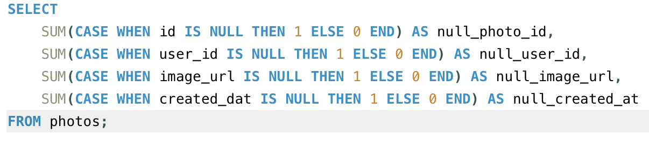
Query - To ensure there are no Null Values we use
Insight - By using these queries we can avoid unreliable data and make sure the data we have is clean

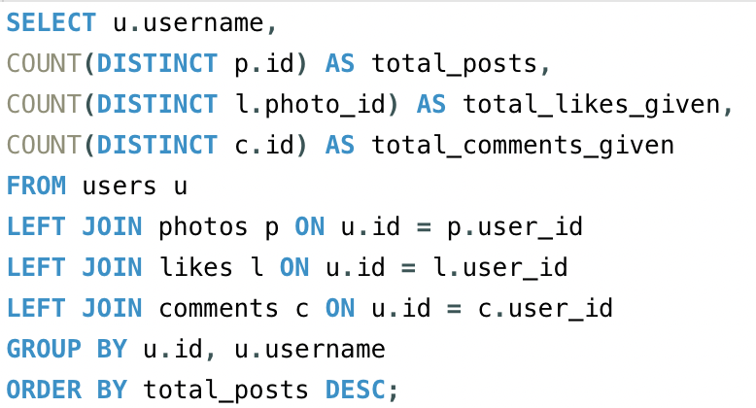
- What is the distribution of user activity levels (e.g., number of posts, likes, comments) across the user base?
Query – To Calculate the Total Activity for each user

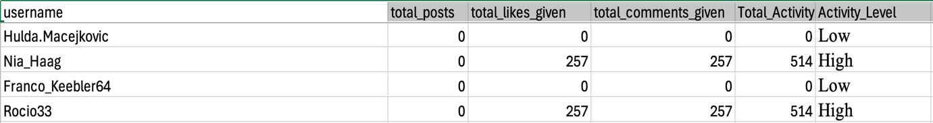
We get our data using =IF(E6<=5,"Low",IF(E6<=20,"Medium","High"))

We generate a pivot table for clear understanding
Pivot Table –
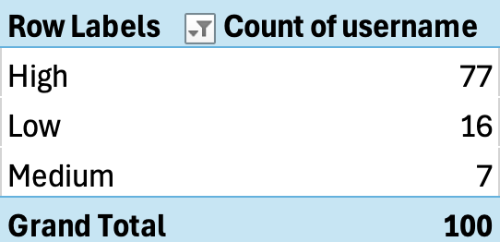

Chart –

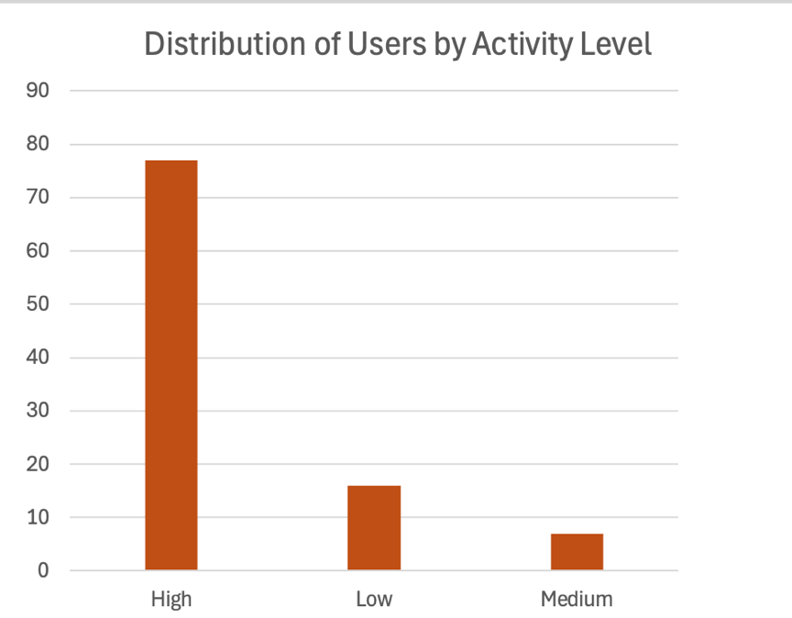

Insight - 77% of users belong to the High Activity segment, a highly active user base contributes positively to content creation, user interactions, and overall platform growth so to retain them we can reward them through loyalty programs and early access to new functionalities to maintain their engagement and for low and medium active users we can encourage higher participation through personalized content and can launch re-engagement campaigns using email reminders, push notifications, trending content suggestions.

- Calculate the average number of tags per post (photo_tags and photos tables).
Query – To Calculate the average number of tags across all tagged photos.

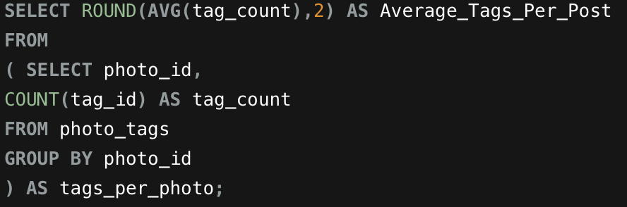

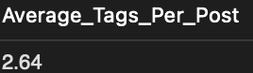
By running this query in our database we get average number of tags across all tagged photos which is 2.64

Insight - On average, each Instagram post contains approximately 3 hashtags, suggesting that users rely on hashtags to improve content visibility
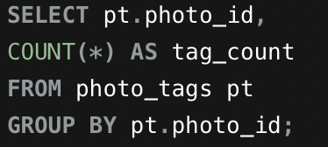
Number of Tags across all photos -

When shown in charts looks like -
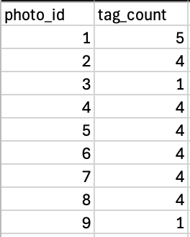

By counting the total number of tags for each photo, we can represent the data visually.

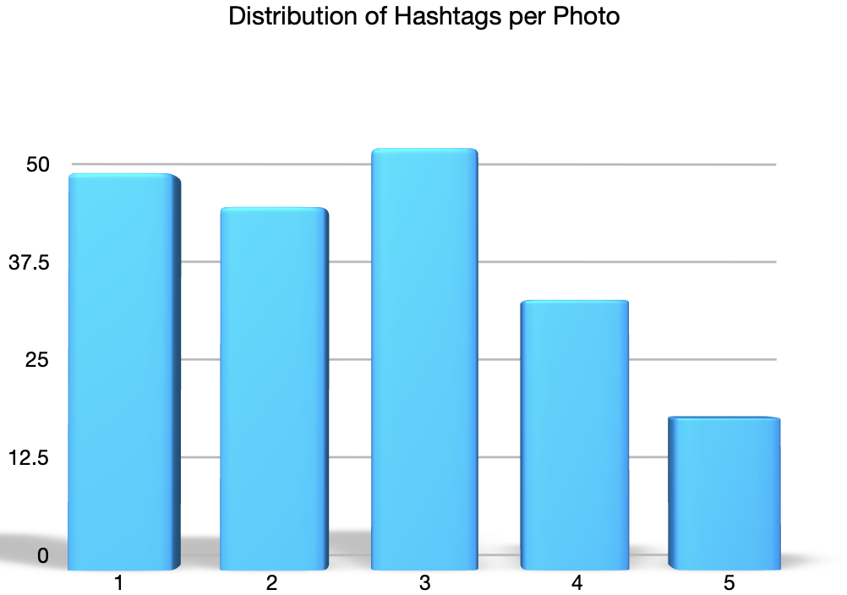

Insight - Most posts contain between 2 and 3 hashtags, indicating that users generally use a moderate number of hashtags rather than overusing the tags we can be generating AI powered hashtag recommendations based on image content, captions, and trending topics using the user data and providing relevant hashtag suggestions.

- Identify the top users with the highest engagement rates (likes, comments) on their posts and rank them.

Query – To find users with highest engagement through most number of likes and comments
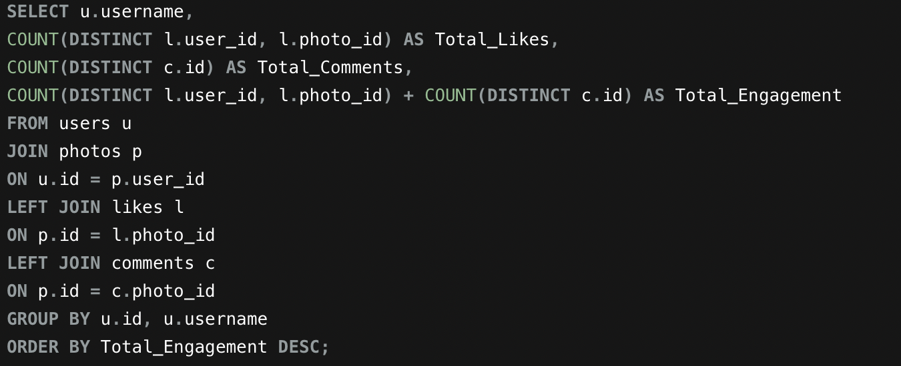

Top Results shown are -
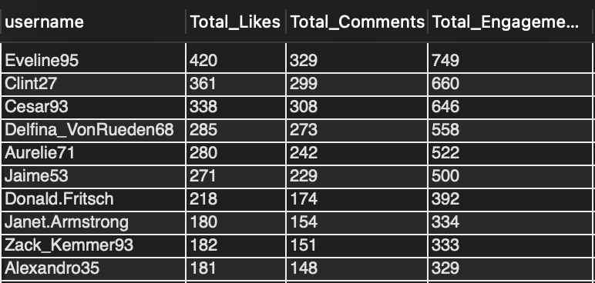

The above data shows that a small group of users consistently receive significantly higher engagement than others. These users generate a large number of likes and comments, indicating strong audience interaction and higher content popularity

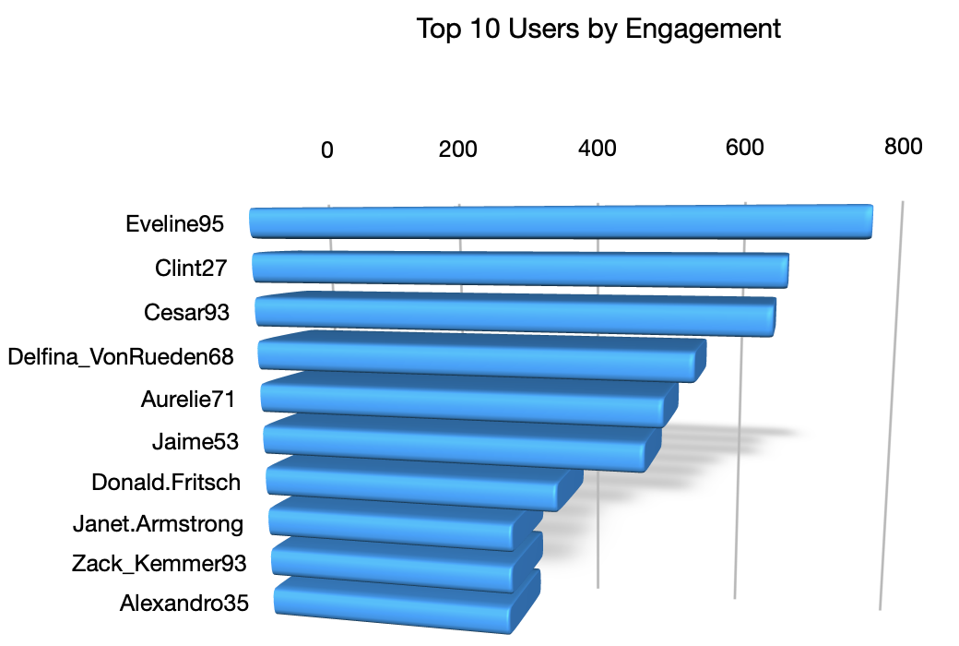

Insight – These are highly engaged users and they play a crucial role in maintaining platform activity by creating content that attracts audience interaction, we should recognize high engagement users through creator incentive programs, exclusive features, and brand partnership initiatives to maintain platform engagement and retention.

- Which users have the highest number of followers and followings?

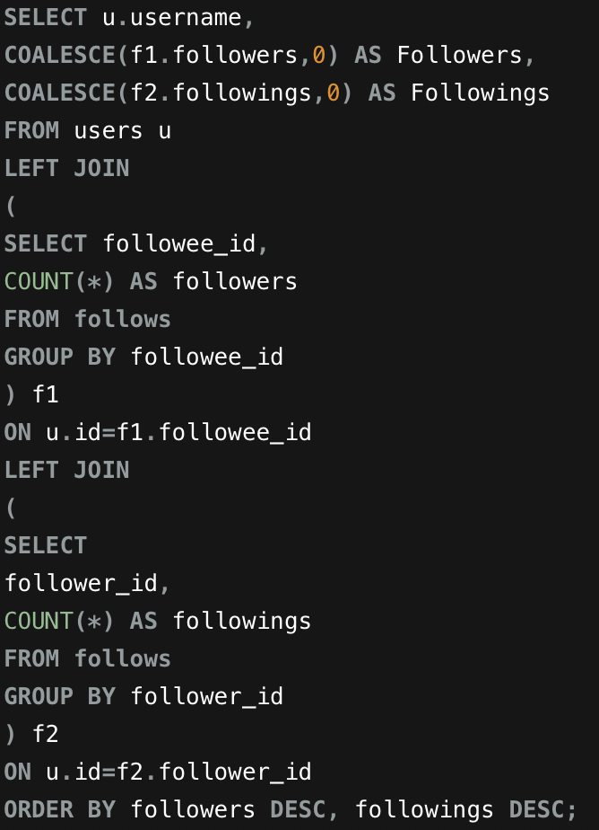
Query – To find out highest number of followers and followings

The results for top 5 highest number of followers are
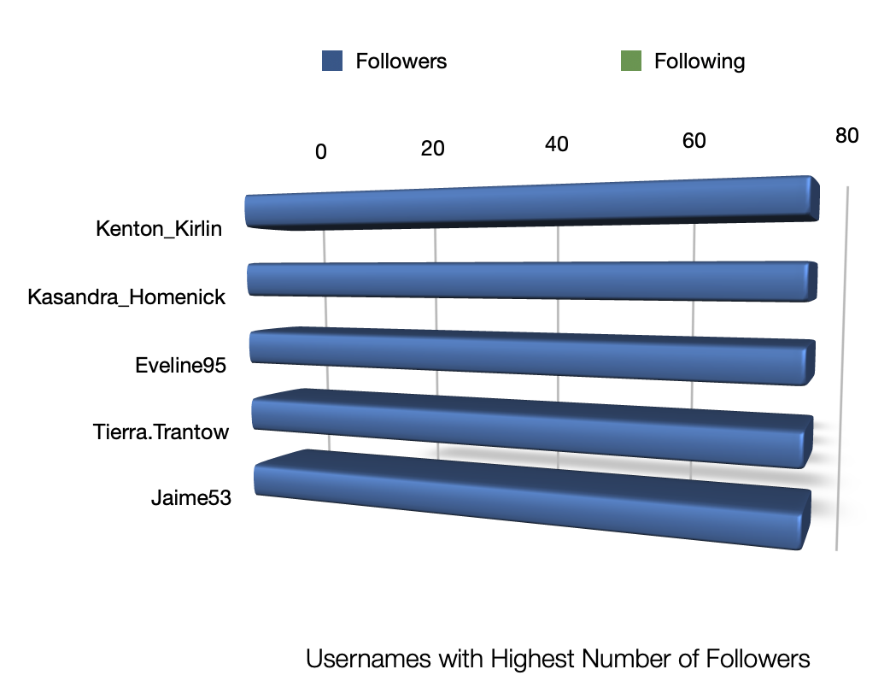

The results for top 5 highest number of Following in accordance to the followers are
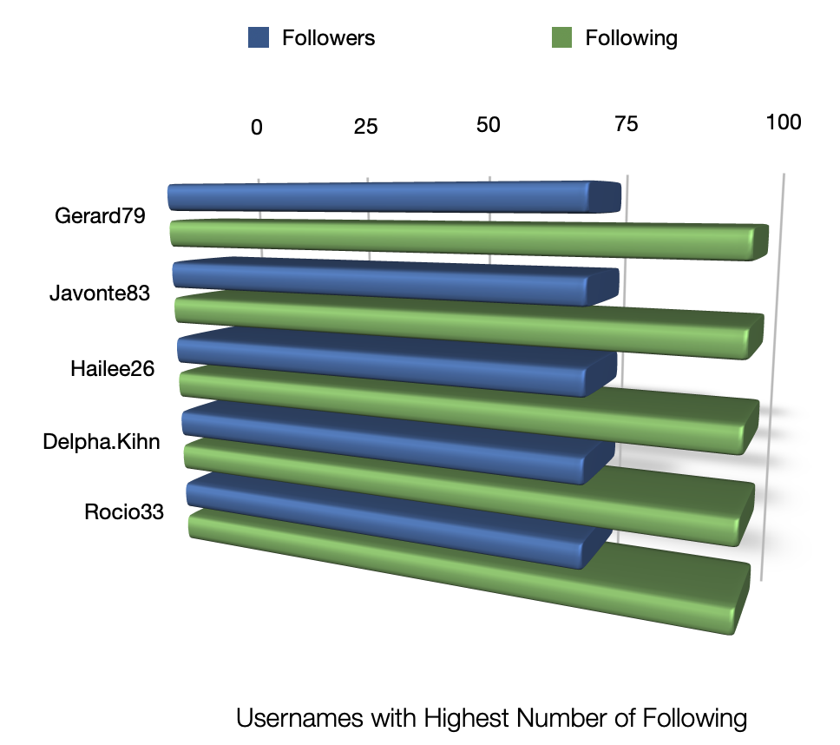

The above analysis shows that few group of users have significantly higher follower counts than the rest of the user base. Some users also follow many accounts reflecting active networking behaviour while others have more followers than followings thus indicating greater influence on the platform.

Insight – Users with high number of followers represent influential members of the platform who can increase the engagement and content visibility, similarly we can know that users high following are typically more active in discovering and interacting with content.

So,meta should be encouraging highfollower users through creator rewards and collaboration programs. Users with high following activity can be targeted with personalized content recommendations to improve engagement and content discovery across the platform

- Calculate the average engagement rate (likes, comments) per post for each user.

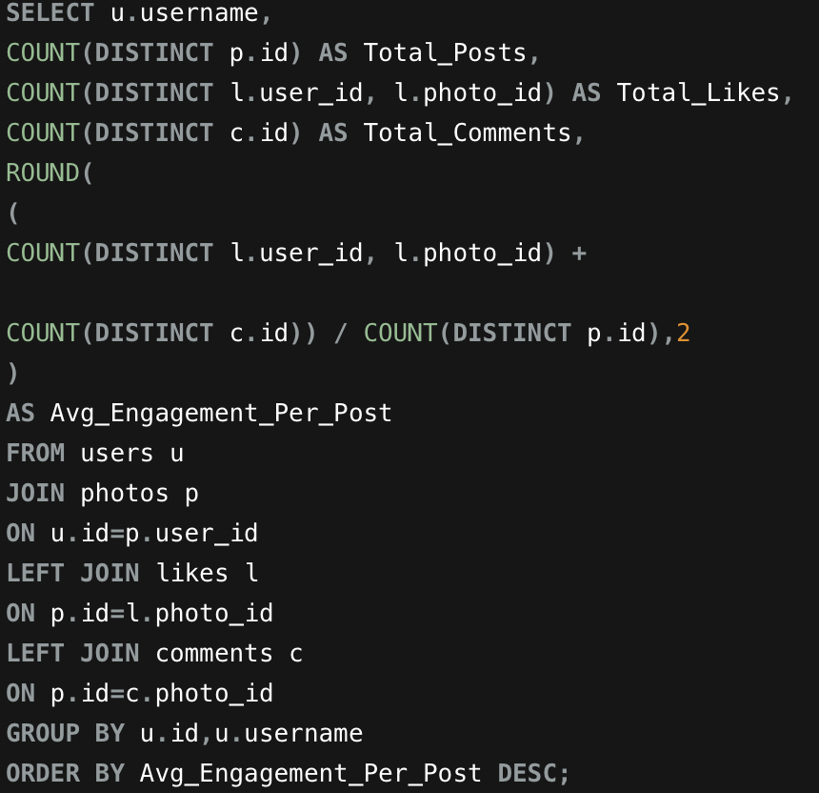
Approach Used – counting total number of posts published by the user along with total count of likes and comments received on the user posts, then we calculate the average engagement by summing up count of likes and comments with respect to number of posts
Query – To achieve the average engagement for each user

username | Total_Posts | Total_Likes | Total_Comments | Avg_Engagement_Per_Post
Meggie_Doyle | 1 | 41 | 34 | 75.00
Jaylan.Lakin | 1 | 38 | 35 | 73.00
Granville_Kutch | 1 | 37 | 34 | 71.00
Kenneth64 | 1 | 39 | 31 | 70.00
Damon35 | 1 | 40 | 28 | 68.00
Rick29 | 4 | 140 | 132 | 68.00
Karley_Bosco | 1 | 36 | 32 | 68.00
Odessa2 | 1 | 36 | 31 | 67.00
Janet.Armstrong | 5 | 180 | 154 | 66.80
Zack_Kemmer93 | 5 | 182 | 151 | 66.60

The results achieved are in the order of user with highest engagement rate
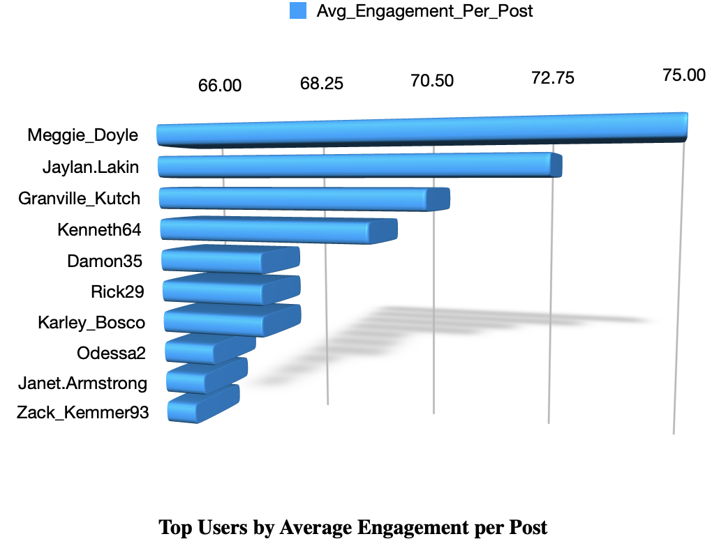
The shows that some users receive significantly higher engagement per post than others even when these users may not punlish the highest number of posts each post attracts a large number of audience interaction indicating consistently high quality content.

Insight – we should identify users with higher engagement rate and provide them with tools focusing of their particular domain, promotional, advertisement and collaboration opportunities.

- Get the list of users who have never liked any post (users and likes tables)

Approach Used – Bring up all user data from users table and compare the same with the likes table, then we find for user_id not present in the likes table.
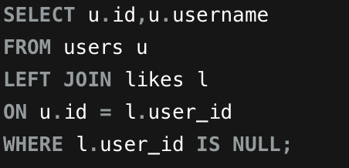
Query – To find out users who never liked any post

With the query above total of 23 users were identified who never liked any post but here are only 10 records shown for clarity

Here is the list of usernames along with their user_id who never liked any post

id | username
1 | Kenton_Kirlin
7 | Kasandra_Homenick
23 | Eveline95
25 | Tierra.Trantow
29 | Jaime53
34 | Pearl7
45 | David.Osinski47
49 | Morgan.Kassulke
51 | Mariano_Koch3

These users have not got involved in basic engagement activities by so we can consider them as inactive or less engaged users

Insight – We can target these inactive or low engaged users through notifications, personalized favorable content to improve user retention.

- How can you leverage user-generated content (posts, hashtags, photo tags) to create more personalized and engaging ad campaigns?)

Approach Used – We use Hashtags to determine popular topics and interests of the user

Query – to find the popular hashtags used along with total engagement

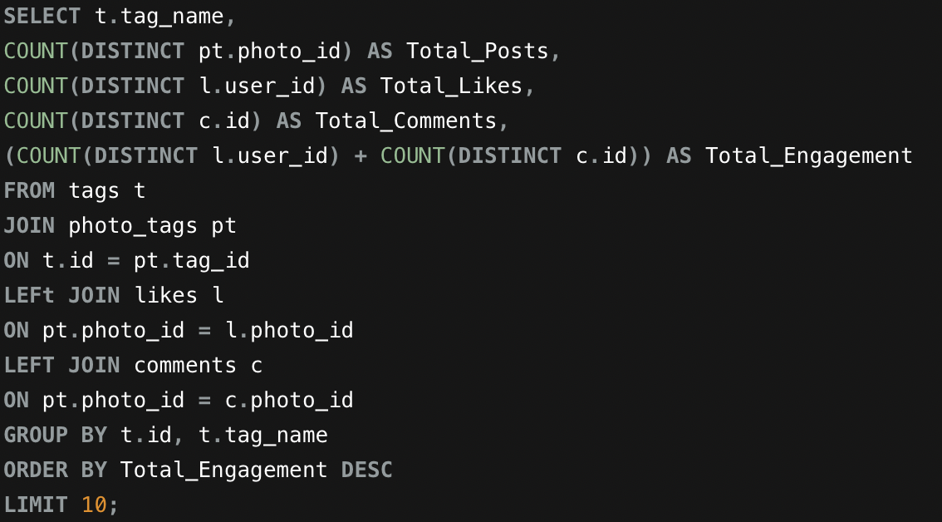

Here are the hashtags used for higher user engagement

tag_name | Total_Posts | Total_Likes | Total_Comments | Total_Engagement
smile | 59 | 77 | 1725 | 1802
beach | 42 | 77 | 1216 | 1293
party | 39 | 77 | 1151 | 1228
fun | 38 | 77 | 1089 | 1166
food | 24 | 77 | 727 | 804
lol | 24 | 77 | 691 | 768
concert | 24 | 77 | 676 | 753
hair | 23 | 77 | 652 | 729
happy | 22 | 77 | 625 | 702
beauty | 20 | 77 | 604 | 681

This shows that the hashtags that generate the highest overall engagement based on the combined number of likes and comments received by the posts associated with them.
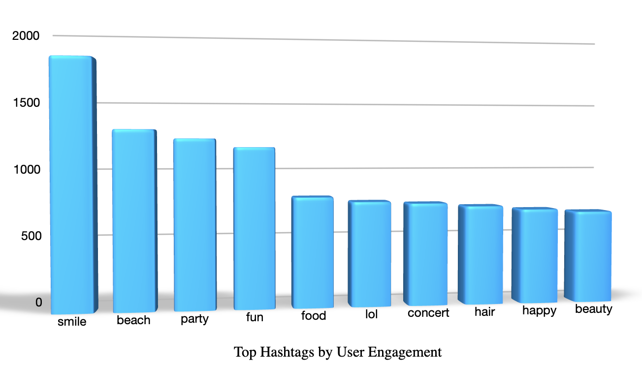

Insights – User generated content provides valuable information about user interests, preferences, and engagement behavior by using the Hashtags consistently for higher engagement indicates topics that resonate strongly with users, by analyzing these patterns we can create personalized advertising campaigns that target users based on the hashtags they use or interact with.

We can also leverage user generated content by implementing AI driven interest profiling based on frequently used and highly engaging hashtags and we can make sure that advertisements should be personalized according to user’s posting behavior, hashtag usage, and interaction history.

- Are there any correlations between user activity levels and specific content types (e.g., photos, videos, reels)? How can this information guide content creation and curation strategies?

Approach- The current dataset only contains the user activity levels associated only on photo – based posts, the analysis that need to be done is only focused on how photo posting activities relates to user engagement.

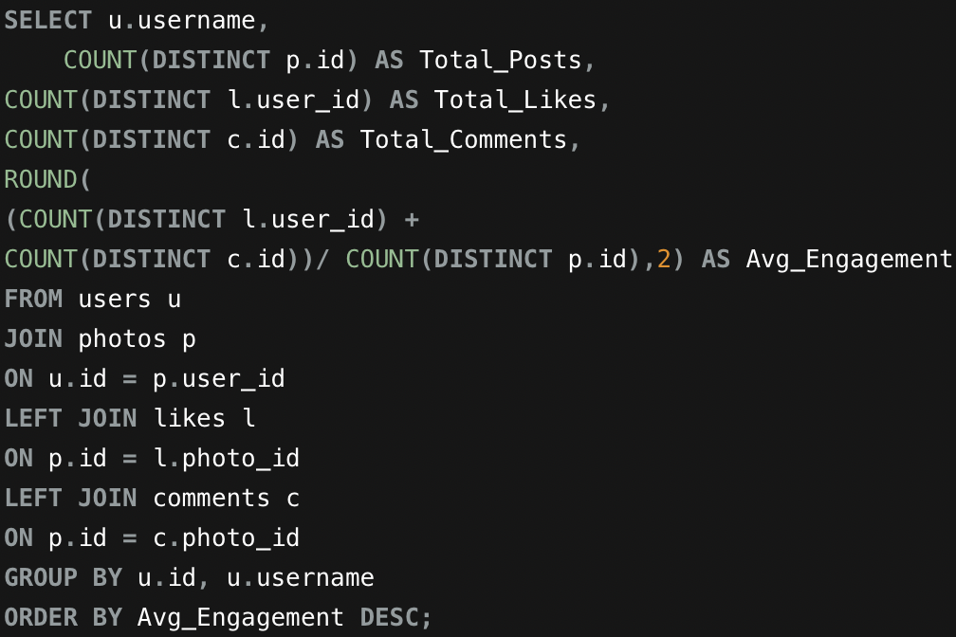
Query – To find out user activity levels with posts

So, here we count total number of posts created by each user and counting all the likes and comments by comparing them to the posts

Top 10 users supporting the data

username | Total_Posts | Total_Likes | Total_Comments | Avg_Engagement
Meggie_Doyle | 1 | 41 | 34 | 75.00
Jaylan.Lakin | 1 | 38 | 35 | 73.00
Granville_Kutch | 1 | 37 | 34 | 71.00
Kenneth64 | 1 | 39 | 31 | 70.00
Damon35 | 1 | 40 | 28 | 68.00
Karley_Bosco | 1 | 36 | 32 | 68.00
Odessa2 | 1 | 36 | 31 | 67.00
Jayson65 | 1 | 38 | 28 | 66.00
Kelsi26 | 1 | 39 | 27 | 66.00
Erick5 | 1 | 36 | 29 | 65.00
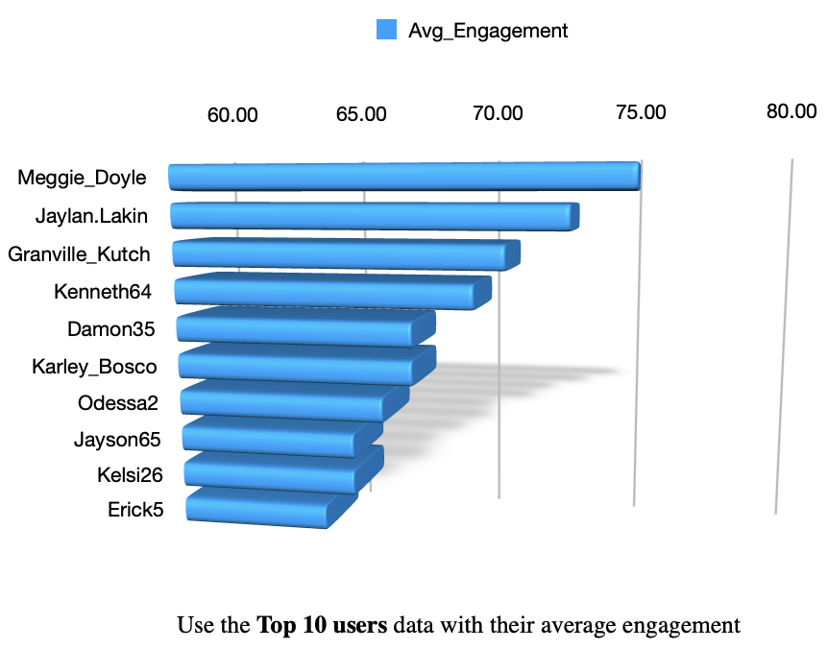
This chart helps visualize whether users who post more tend to receive higher or lower engagement.

Insights - The above dataset contains only photo based posts so a direct comparison with videos or reels is not possible but the analysis shows that posting activity alone does not guarantee higher engagement.

Some users with fewer posts achieve higher average engagement than users who post more frequently suggesting that content quality and audience relevance are more influential than posting volume.

We should focus on promoting content based on engagement metrics rather than posting frequency

- Calculate the total number of likes, comments, and photo tags for each user.

Approach – Count total number of likes, comments and photo tags across each users photos
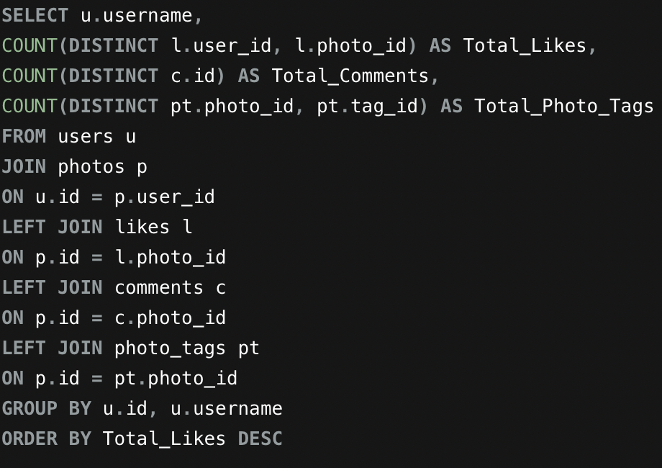

Top 10 users with HIGHEST average_engagement rate
Eveline95 | 420 | 329 | 24
Clint27 | 361 | 299 | 26
Cesar93 | 338 | 308 | 16
Delfina_VonRueden68 | 285 | 273 | 17
Aurelie71 | 280 | 242 | 20
Jaime53 | 271 | 229 | 15
Donald.Fritsch | 218 | 174 | 15
Zack_Kemmer93 | 182 | 151 | 7
Alexandro35 | 181 | 148 | 7
Janet.Armstrong | 180 | 154 | 5

This compares the total number of likes, comments, and photo tags associated with each user's posts. Users with higher likes and comments generally receive stronger audience engagement

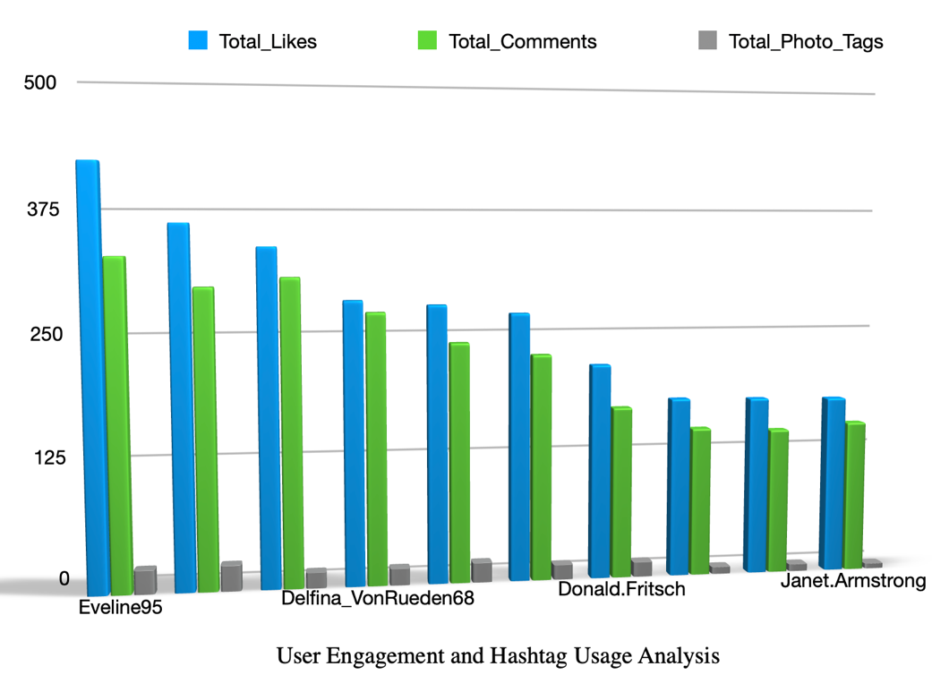

Insights - Combining likes, comments, and hashtag usage provides a comprehensive view of user performance. The number of photo tags indicates how actively hashtags are used to improve content visibility. Some users achieve high engagement with relatively fewer tags suggesting that content quality and audience relevance are more influential than simply using more hashtags

We can encourage creators to use relevant hashtags while focusing on producing high-quality content that drives engagement. By analyzing the relationship between hashtag usage and audience interactions.

- Rank users based on their total engagement (likes, comments, shares) over a month.

Approach – we count total number of likes and comments received on the user posts for that particular month i.e. (06/2026) by combining the count of total number of likes and comments we get total engagement of the user for that particular month

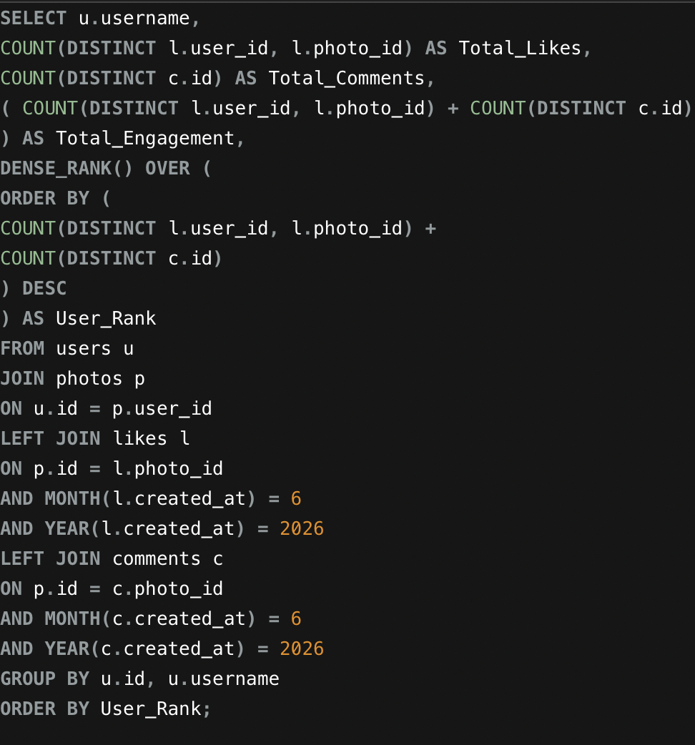
Query – to rank users according to total engagement received for a particular month

By using the above query we get ranks for the users with highest engagement but here are our top 10 users

username | Total_Likes | Total_Comments | Total_Engagement | User_Rank
Eveline95 | 420 | 329 | 749 | 1
Clint27 | 361 | 299 | 660 | 2
Cesar93 | 338 | 308 | 646 | 3
Delfina_VonRueden68 | 285 | 273 | 558 | 4
Aurelie71 | 280 | 242 | 522 | 5
Jaime53 | 271 | 229 | 500 | 6
Donald.Fritsch | 218 | 174 | 392 | 7
Janet.Armstrong | 180 | 154 | 334 | 8
Zack_Kemmer93 | 182 | 151 | 333 | 9
Alexandro35 | 181 | 148 | 329 | 10
Chart – Horizontal Bar Chart
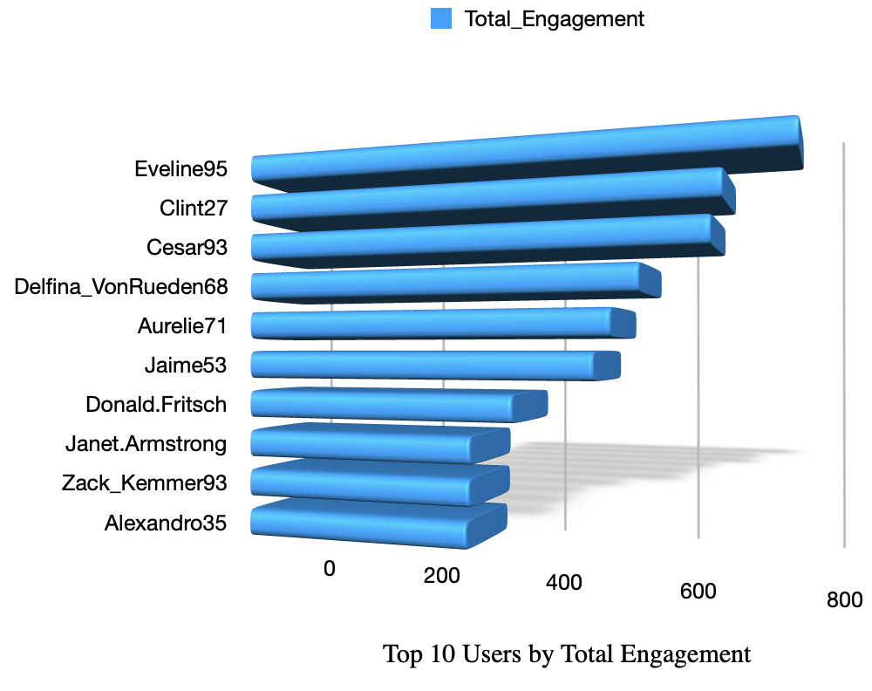

Insight - The analysis shows that Eveline95 achieved the highest total engagement followed by Clint27 and Cesar93.

There is a noticeable gap between the engagement from the 4th rank user but this suggests that these users consistently produce content that attracts high audience interaction.

Users with the highest engagement represent valuable creators who significantly influence audience activity on the platform.

Their content consistently receives large numbers of likes and comments, making them ideal candidates for influencer marketing campaigns, premium creator programs, and personalized content recommendations.

- Retrieve the hashtags that have been used in posts with the highest average number of likes. Use a CTE to calculate the average likes for each hashtag first.

Approach – Count total number of likes received for each photo and associate it with the hashtags used for each photo then we use CTE(Common Table Expression) to calculate average likes for each hashtag and arrange them in ranked order

Query – to find out average likes for each hashtag received for each photo
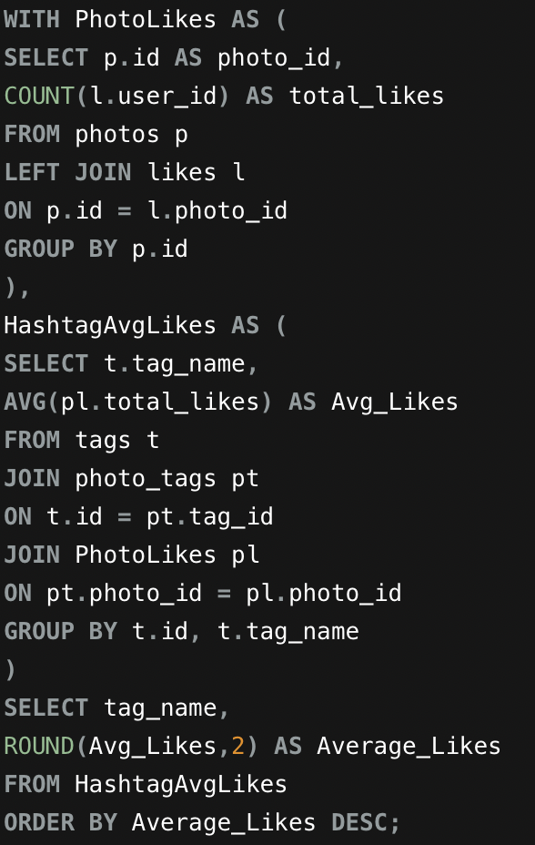

Top 10 Hashtags we got using the above query are –

tag_name | Average_Likes
dreamy | 35.75
beauty | 34.95
stunning | 34.94
delicious | 34.93
foodie | 34.73
happy | 34.59
hair | 34.52
photography | 34.50
beach | 34.48
style | 34.47
Horizontal Bar Chart
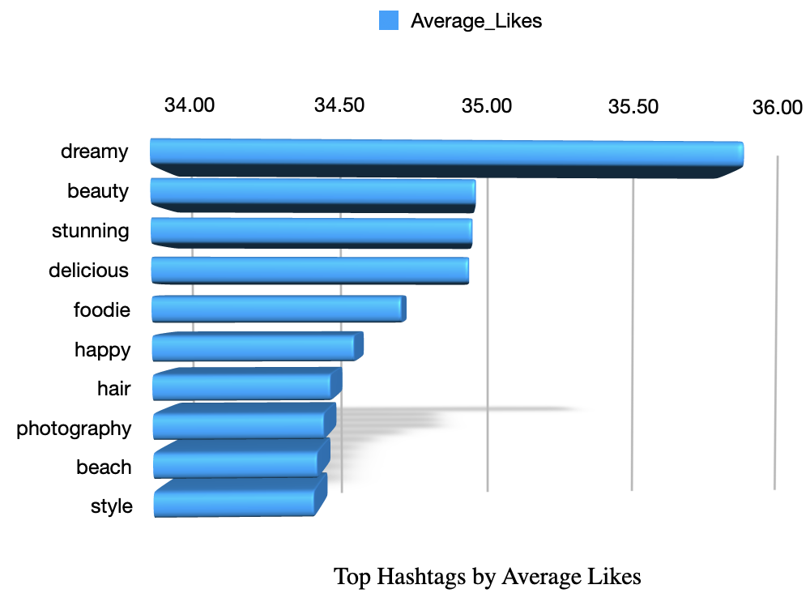

Insights - The above data reveals that certain hashtags receive a higher average number of likes than others. This indicates that posts containing these hashtags tend to generate greater audience engagement

High performing hashtags reflect topics that resonate strongly with the meta community, by identifying hashtags associated with higher average likes meta can improve content recommendations. Meta should recommend highengagement hashtags during post creation user driven suggestions.

- Retrieve the users who have started following someone after being followed by that person
Approach - To identify users who followed someone back, we compare the follows table with itself. If User A follows User B and User B also follows User A, it indicates a (follow back) relationship
Query – Self Join is used to find the ids from its own table
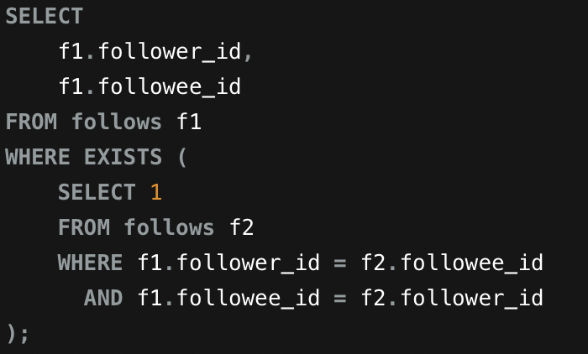

Insight - The query checks whether every follow relationship has a corresponding reverse follow relationship.
If both users follow each other, they are identified as mutual followers.
Mutual followers generally represent stronger user relationships and higher engagement between users, we can use this data to bring more users onto the platform and strengthen community interactions

Subjective Questions

- Based on user engagement and activity levels, which users would you consider the most loyal or valuable? How would you reward or incentivize these users?

Approach - to identify the platform's most loyal and valuable users by evaluating their activity levels and engagement metrics.

Business Problem – Meta has asked to find out most loyal and valuable users by evaluating their activity levels and engagement metrics so that they can be rewarded, retained, and encouraged to continue creating high-quality content.

Preferred Criteria –users with highest Total Engagement identifies users who consistently contribute to overall platform activity, it can be influenced by a higher posting frequency. So we will also consider average Engagement per Post highlights users whose content generates stronger audience interaction regardless of the number of posts.

SQL Analysis

Analysis 1 – we will be considering Average Engagement per Post

SQL Query

SQL Output for Analysis 1 –

username | Total_Posts | Total_Likes | Total_Comments | Avg_Engagement_Per_Post
Meggie_Doyle | 1 | 41 | 34 | 75.00
Jaylan.Lakin | 1 | 38 | 35 | 73.00
Granville_Kutch | 1 | 37 | 34 | 71.00
Kenneth64 | 1 | 39 | 31 | 70.00
Damon35 | 1 | 40 | 28 | 68.00
Rick29 | 4 | 140 | 132 | 68.00
Karley_Bosco | 1 | 36 | 32 | 68.00
Odessa2 | 1 | 36 | 31 | 67.00
Janet.Armstrong | 5 | 180 | 154 | 66.80
Zack_Kemmer93 | 5 | 182 | 151 | 66.60

Analysis 2 – we will be considering Total User Engagement

SQL Query -
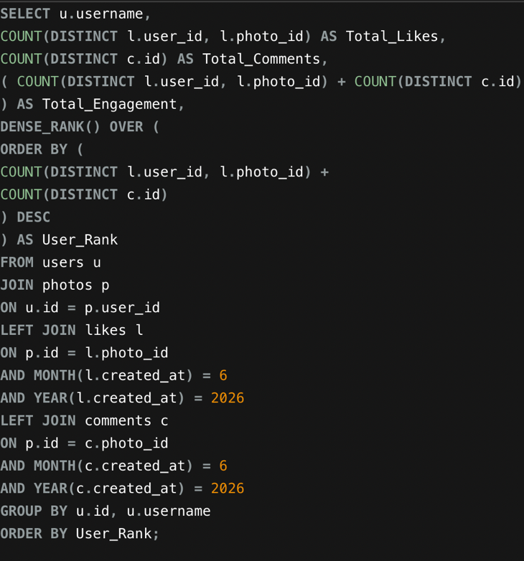

SQL Output for Analysis 1 –

username | Total_Likes | Total_Comments | Total_Engagement | User_Rank
Eveline95 | 420 | 329 | 749 | 1
Clint27 | 361 | 299 | 660 | 2
Cesar93 | 338 | 308 | 646 | 3
Delfina_VonRueden68 | 285 | 273 | 558 | 4
Aurelie71 | 280 | 242 | 522 | 5
Jaime53 | 271 | 229 | 500 | 6
Donald.Fritsch | 218 | 174 | 392 | 7
Janet.Armstrong | 180 | 154 | 334 | 8
Zack_Kemmer93 | 182 | 151 | 333 | 9
Alexandro35 | 181 | 148 | 329 | 10

Visualization

Top 10 Users by Average Engagement per Post

Top 10 Users by Top Engagement

Insight – We’ve considered two different tables to consider for loyal and valuable, users from highest average engagement per post indicates even though they post less frequently but their audience are consistent
But from the other total engagement table we get to know that these users have sustained audience interaction through posting multiple posts
Janet.Armstrong and Zack_Kemmer93 these users appear in both the tables showcasing that maintain a good balance between consistent posting activity and strong engagement per post

Recommendation – we can consider these user - Meggie_Doyle, Jaylan.Lakin, Granville_Kutch, Kenneth64 from Highest Average Engagement per Post and Eveline95, Clint27, Cesar93, Delfina_VonRueden68 from highest total engagement. We can also consider Janet.Armstrong and Zack_Kemmer93 for the loyal user base as they are good balance between consistent posting activity and strong engagement per post.
For these users we can be offering Higher visibility in Feed, Priority for brand collaborations, Creator badges, Personalized growth support and Early access to new features.

- For inactive users, what strategies would you recommend to re-engage them and encourage them to start posting or engaging again?

Approach - identify inactive users and recommend data-driven strategies to increase their participation, improve user retention and engagement

Criteria Followed - Users with few or no posts, low interaction through likes and comments, and those classified as Low Activity are considered inactive

SQL Analysis

Analysis 1 - Activity Level Distribution

SQL Query – to find out number of posts posted, likes given, comments given by each user and divide them into different batches according to their engagement

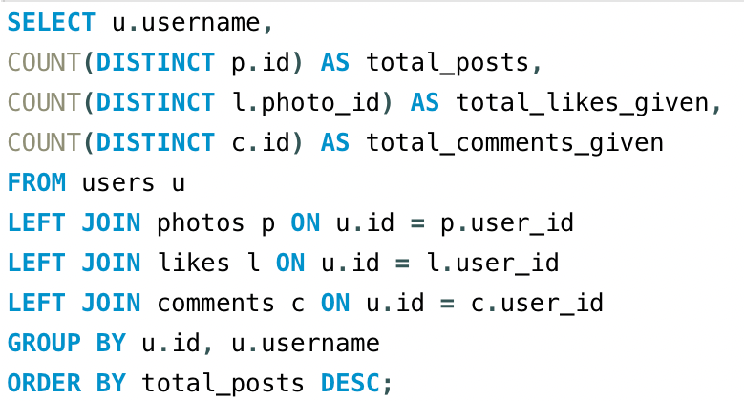

Using this data and segregating accordingly we filter out the user who are come under low activity and engagement on whom we need to focus on, the list given below carries the usernames who come under the specified category

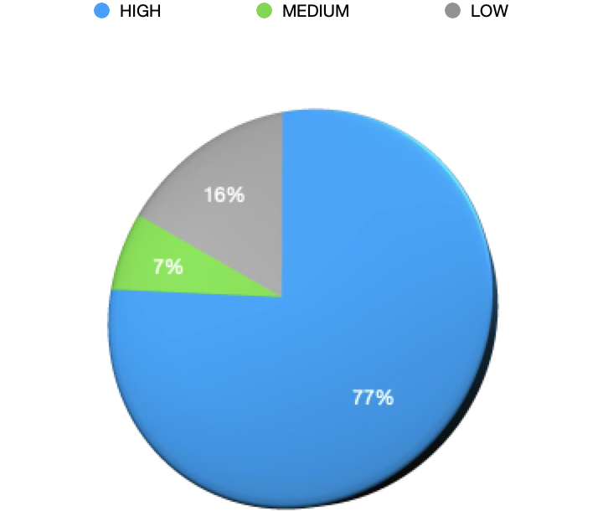

We can also include the users who do not engage with the platform in form of likes etc.

Analysis – 2 - Users Who Have Never Liked Any Post

SQL Query- Identify users with no engagement through likes

The user who never liked any post and showed no engagement through the platform –
id | username
1 | Kenton_Kirlin
7 | Kasandra_Homenick
23 | Eveline95
25 | Tierra.Trantow
29 | Jaime53
34 | Pearl7
45 | David.Osinski47
49 | Morgan.Kassulke
51 | Mariano_Koch3

By comparing both the tables and removing the duplicates we come down to the below given unique usernames who show low activity, these users represent a segment with minimal participation and are at a higher risk of becoming inactive or leaving the platform

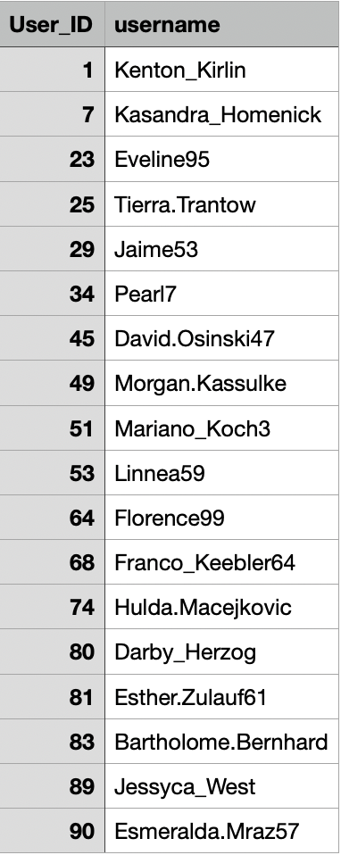

Insight - Users with low activity often require personalized engagement strategies rather than generic notifications. So we can come up with Sending personalized push notifications encouraging them to post again, recommend trending posts and friends content based on their interests, offering the returning user by rewards, exclusive stickers, or limited-time incentives for posting.

- Which hashtags or content topics have the highest engagement rates? How can this information guide content strategy and ad campaigns?

Approach – to analyze and identify hashtags associated with highly engaging content and understand how they can be used to optimize content strategy, increase audience interaction, and improve advertising campaign performance.

Criteria Followed - Hashtag popularity alone does not guarantee high engagement, some hashtags are used frequently but generate average audience interaction while others are used less often but consistently receive higher likes and comments. So, we will using both usage frequency and engagement metrics to identify the most effective hashtags

Analysis 1 - Most Frequently Used Hashtags

SQL Query – to find how many times was each hashtag put to use

By the above query we get to know the top 10 hashtags used along with their total engagement rates
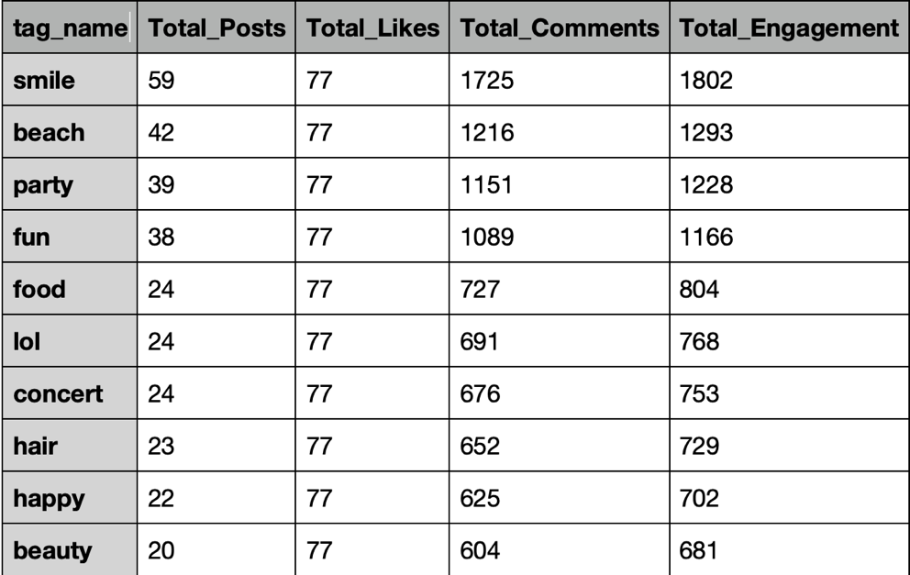

We have the data shown visually on the bases of total_engagement of the hashtags used
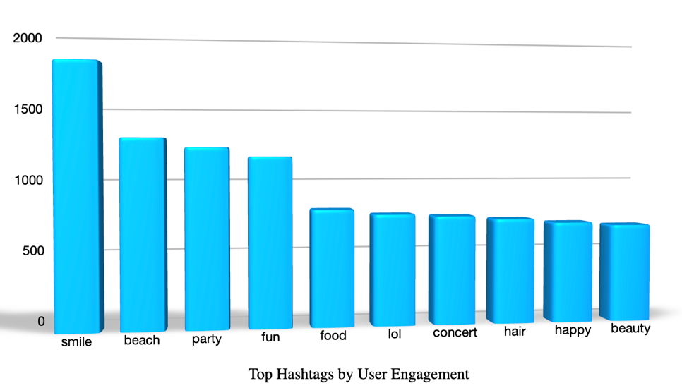

Insight - High-engagement hashtags reflect audience interests and trending topics. Promoting these hashtags improves content discoverability, increases user interaction, and enables advertisers to target audiences more effectively

So we can Recommend high engagement hashtags to creators, prioritize high performing hashtags in search tab , Continuously monitor emerging hashtag trends.

- Are there any patterns or trends in user engagement based on demographics (age, location, gender) or posting times? How can these insights inform targeted marketing campaigns?

Approach – We will be using the user metrics to track and plan the marketing campaigns that can be done from the selected profiles

Criteria Followed – Different users have different demographics and posting times, but the data we considered is of the members with same posting time resonating that high number if users fell that during at nights their content can be reached to greater bounds because of algorithm and help them with their reach.

SQL Analysis - to identify the user engagement on the platform based on their posting times

SQL Query -
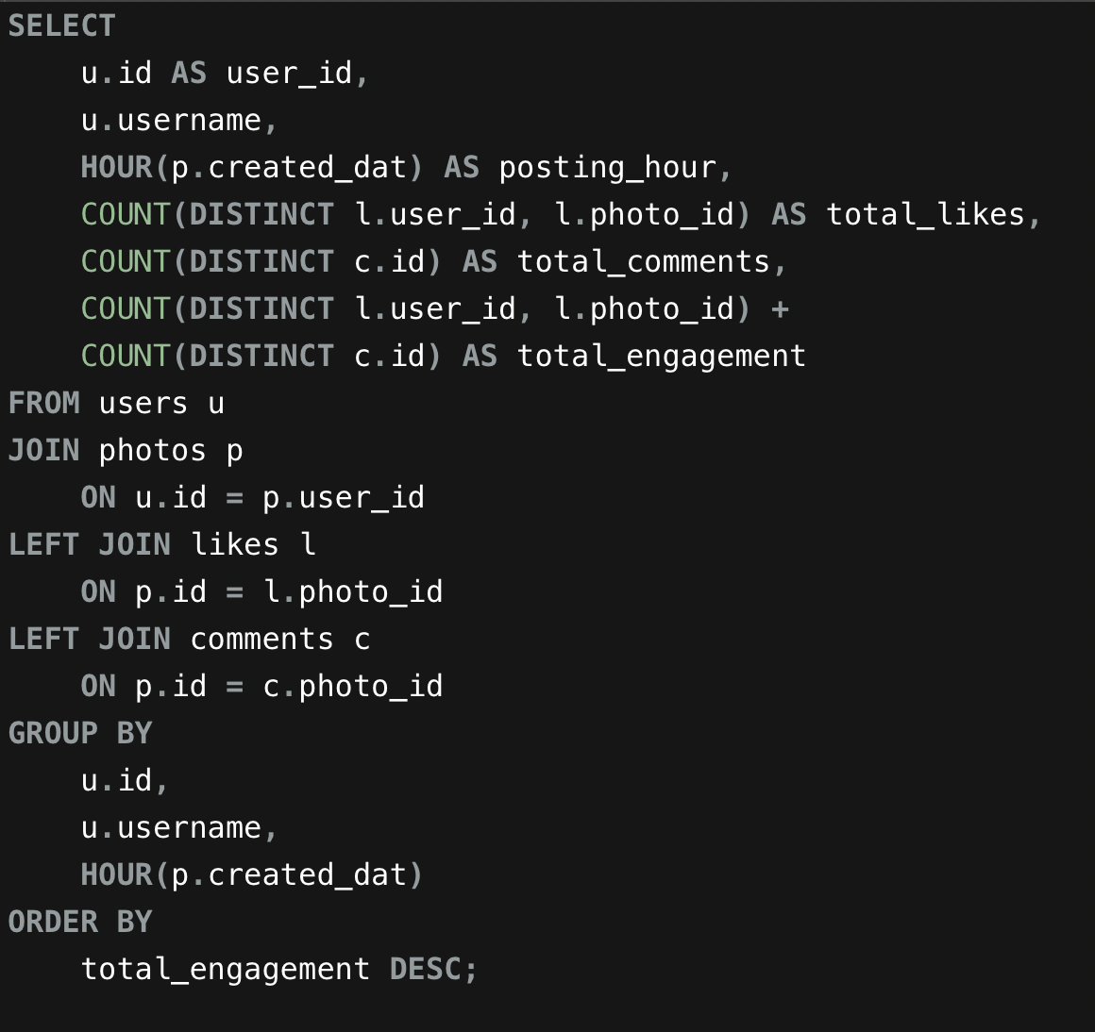

These are the few users who come under above mentioned criteria

user_id | username | posting_hour | total_likes | total_comments | total_engagement
23 | Eveline95 | 20 | 420 | 329 | 749
88 | Clint27 | 20 | 361 | 299 | 660
59 | Cesar93 | 20 | 338 | 308 | 646
86 | Delfina_VonRueden68 | 20 | 285 | 273 | 558
58 | Aurelie71 | 20 | 280 | 242 | 522

Inisghts - certain users who come under specific age groups, locations, or genders may interact more frequently with different types of content.

Example – user from the age group of 14 – 22 are highly active on Reels, trending challenges, gaming, and entertainment content and users between 23 – 30 engage themselves with lifestyle, fitness, travel, technology, and career related content etc.

From the Data above we can be see that posts made during nights could attract higher engagement

Few marketing campaigns that can be suggested are - campaigns should focus on fashion, gaming, music, interactive sessions .
When we move to users who fall under age group of 21–30 years we can be showing them with their personalized ads for fitness brands, travel packages, gadgets, and online learning platforms and by not missing out for the users who mostly new to the platform 31–45, advertisements regarding healthcare, insurance, home appliances, and financial services can be shown.

- Based on follower counts and engagement rates, which users would be ideal candidates for influencer marketing campaigns? How would you approach and collaborate with these influencers?

Approach - To identify users who are best suited for influencer marketing campaigns by analyzing their follower base and engagement performance, selecting influencers based solely on follower count may not always produce successful campaigns. Therefore, it is essential to evaluate both audience size and engagement quality to identify creators capable of delivering better marketing results

Criteria Followed - Users with a large follower base provide greater audience reach, while users with high engagement rates demonstrate stronger audience trust and interaction. Considering both metrics helps identify influencers who can deliver successful marketing campaigns.

SQL Analysis

SQL Query 1 - Users with Highest number of Followers

By using the above query we get to know the users who are having highest number of followers compared to rest of the users

username | total_followers
Kenton_Kirlin | 77
Kasandra_Homenick | 77
Eveline95 | 77
Tierra.Trantow | 77
Jaime53 | 77
Pearl7 | 77
David.Osinski47 | 77
Morgan.Kassulke | 77
Mariano_Koch3 | 77
Esmeralda.Mraz57 | 77

SQL Query 2 - Highest Average Engagement per Post

We will be using the data from the above table to also include users with highest number of engagement on their profile

username | Total_Posts | Total_Likes | Total_Comments | Avg_Engagement_Per_Post
Meggie_Doyle | 1 | 41 | 34 | 75.00
Jaylan.Lakin | 1 | 38 | 35 | 73.00
Granville_Kutch | 1 | 37 | 34 | 71.00
Kenneth64 | 1 | 39 | 31 | 70.00
Damon35 | 1 | 40 | 28 | 68.00
Rick29 | 4 | 140 | 132 | 68.00
Karley_Bosco | 1 | 36 | 32 | 68.00
Odessa2 | 1 | 36 | 31 | 67.00
Janet.Armstrong | 5 | 180 | 154 | 66.80
Zack_Kemmer93 | 5 | 182 | 151 | 66.60

The same data as above has been visualized

SQL Query 3 - User Ranking by Total Engagement

By using the above query we got the top performers in means of engagement

username | Total_Likes | Total_Comments | Total_Engagement | User_Rank
Eveline95 | 420 | 329 | 749 | 1
Clint27 | 361 | 299 | 660 | 2
Cesar93 | 338 | 308 | 646 | 3
Delfina_VonRueden68 | 285 | 273 | 558 | 4
Aurelie71 | 280 | 242 | 522 | 5
Jaime53 | 271 | 229 | 500 | 6
Donald.Fritsch | 218 | 174 | 392 | 7
Janet.Armstrong | 180 | 154 | 334 | 8
Zack_Kemmer93 | 182 | 151 | 333 | 9
Alexandro35 | 181 | 148 | 329 | 10

When its visually represented in form of horizontal bar chart

Insight - The analysis indicates that users with the highest follower counts have the greatest audience reach, while users with the highest engagement rates consistently generate stronger audience interaction, follower count determines the potential reach of an influencer, whereas engagement rate reflects audience trust and content quality

So we can partner with the creators and select influencers who maintain both high follower counts and strong engagement, prioritize creators appearing in multiple performance analyses, develop long-term partnerships instead of one time collaborations, and at last we can also match influencers with brands that align with their content category.

- Based on user behavior and engagement data, how would you segment the user base for targeted marketing campaigns or personalized recommendations?

Approach - To segment the Instagram user base into meaningful groups based on user activity, engagement, and interaction patterns, treating every user the same reduces marketing effectiveness. Segmenting users based on behavior allows Instagram to deliver personalized content, improve user retention, and maximize advertising performance

Criteria Followed - Users are segmented based on activity level, engagement performance and audience reach.

SQL Analysis

SQL Query 1 - to classify users according to their engagement

Then we can segregate the users accordingly

This tells us about users User Activity Distribution

SQL Query 2 – to find out users by total engagement

Here are top 10 users with highest engagement in a month

username | Total_Likes | Total_Comments | Total_Engagement | User_Rank
Eveline95 | 420 | 329 | 749 | 1
Clint27 | 361 | 299 | 660 | 2
Cesar93 | 338 | 308 | 646 | 3
Delfina_VonRueden68 | 285 | 273 | 558 | 4
Aurelie71 | 280 | 242 | 522 | 5
Jaime53 | 271 | 229 | 500 | 6
Donald.Fritsch | 218 | 174 | 392 | 7
Janet.Armstrong | 180 | 154 | 334 | 8
Zack_Kemmer93 | 182 | 151 | 333 | 9
Alexandro35 | 181 | 148 | 329 | 10

The above users total_engagement and ranking is showed in a bar chart below

SQL Query 3 – to identify users with large number of followers

Users with highest following

username | total_followers
Kenton_Kirlin | 77
Kasandra_Homenick | 77
Eveline95 | 77
Tierra.Trantow | 77
Jaime53 | 77
Pearl7 | 77
David.Osinski47 | 77
Morgan.Kassulke | 77
Mariano_Koch3 | 77
Esmeralda.Mraz57 | 77

And we will also be taking the query where we considered engagement of hashtag with respect to each post

SQL Query 4 - Understanding user interests through hashtag engagement

Below are the most liked, used and engaging hashtags on the platform

tag_name | Total_Posts | Total_Likes | Total_Comments | Total_Engagement
smile | 59 | 77 | 1725 | 1802
beach | 42 | 77 | 1216 | 1293
party | 39 | 77 | 1151 | 1228
fun | 38 | 77 | 1089 | 1166
food | 24 | 77 | 727 | 804
lol | 24 | 77 | 691 | 768
concert | 24 | 77 | 676 | 753
hair | 23 | 77 | 652 | 729
happy | 22 | 77 | 625 | 702
beauty | 20 | 77 | 604 | 681

These hashtags are used to make the posts more relevant and to showcase the user interests through the platform, below is chart represented visually using the above data
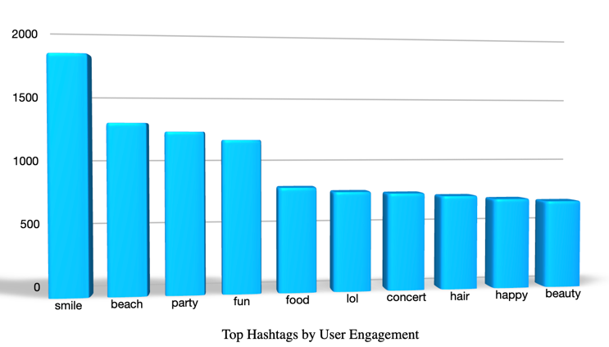

Insight - Behavioral segmentation allows Meta to deliver the right content and marketing campaigns to the right users. Inactive users can be encouraged to return through personalized re engagement campaigns recommended segment specific strategies as in recommend trending hashtags, offer loyalty rewards to the active users, suggest collaboration opportunities, recommend optimal hashtags for the emerging creators and final strategy is for the inactive /low engagement users, we can deliver personalized push notifications, offer rewards for returning to the platform and send recommendations based on previous interests.

- If data on ad campaigns (impressions, clicks, conversions) is available, how would you measure their effectiveness and optimize future campaigns?

Approach – we will be using the metrics we received from the campaign data impressions, clicks, conversions, advertising cost, and revenue if available

Impressions - Shows how many times an advertisement was displayed to users, higher the number of impressions the larger is the reach for the advertisement

Click Through Rate (CTR) - It measures how many users clicked the advertisement after seeing it
To calculate this we use - Formula: CTR = (Clicks ÷ Impressions) × 100

Conversion Rate - It measures how many users completed the desired action, example - making a purchase or signing up.
Formula to find this - Conversion Rate = (Conversions ÷ Clicks) × 100

Cost Per Click (CPC) - It indicates the average amount spent for each click.
Formula:
CPC = Total Advertising Cost ÷ Total Clicks
The lower of CPC the better it is

Return on Investment (ROI) - It measures how profitable an advertising campaign is.
Formula:
ROI = ((Revenue − Advertising Cost) ÷ Advertising Cost) × 100

These campaigns can be improved by using more attractive images, videos, headlines, and target the right audience, create better landing pages, clear call to action buttons, and simplify the purchase or sign-up process and invest more in high performing campaigns and reduce spending on campaigns that produce poor results.

- How can you use user activity data to identify potential brand ambassadors or advocates who could help promote Instagram's initiatives or events?

Approach – we will be considering users with active participation and high engagement suitable to represent and promote meta’s initiatives, campaigns, and events.

Criteria Followed – We will not only be considering users with high followers we will also be considering users who maintain high activity levels, consistently generate engagement, and actively participate in the platform are more suitable ambassadors because they demonstrate both loyalty and influence within the community

SQL Analysis
We will be considering user activity level to know how many users fall under the suggested idea

By this means we know that there are active participation users on our platform now we will be looking out for few other metrics

Users possessing high followers count can also be taken into consideration because of their reach

username | total_followers
Kenton_Kirlin | 77
Kasandra_Homenick | 77
Eveline95 | 77
Tierra.Trantow | 77
Jaime53 | 77
Pearl7 | 77
David.Osinski47 | 77
Morgan.Kassulke | 77
Mariano_Koch3 | 77
Esmeralda.Mraz57 | 77
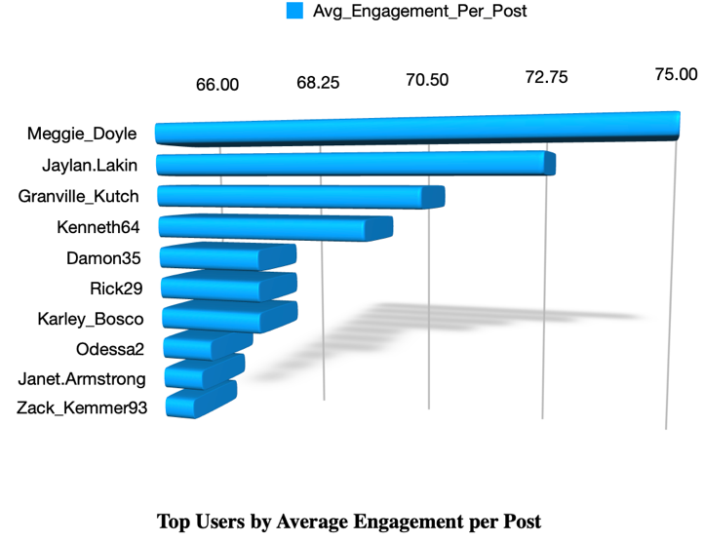
Now that we got the users with most number of followers on the platform, we will now see users with higher average engagement per post

Even though few users have fewer posts on their profile their reach is massive whom we can consider

Now we can consider the total of all including-likes, comments etc on the users profile based on their posts in a ranked order

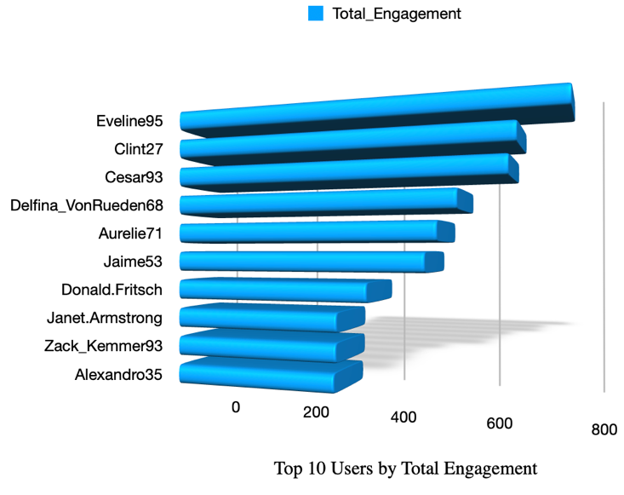

By considering above metrics we have drawn out few names who are most likely eligible for brand ambassador program-

1 - Janet.Armstrong this user appears in both Top Average Engagement per Post and Top Total Engagement.
2 - Zack_Kemmer93 Strong performance in both engagement analyses, demonstrating
3 - Eveline95 Ranked #1 in Total Engagement
4 - Clint27 Ranked #2 in Total Engagement
5 - Cesar93 Ranked #3 in Total Engagement
6 - Delfina_VonRueden68 High overall engagement
7 - Aurelie71 Strong engagement metrics
8 - Jaime53 High total engagement and active participation
9 - Donald.Fritsch Consistently high engagement
10 - Rick29 One of the highest average engagement-per-post performers with multiple posts

The above users are selected on the bases of High Total Engagement, High Average Engagement per Post and Consistent Activity on the platform.

- How would you approach this problem, if the objective and subjective questions weren't given?

Approach – We will use the available user data such as posts, likes, comments, followers, hashtags, and user activity to understand user behaviour and identify ways to improve engagement, retain existing users, and attract new users.

Key Metrics

User Engagement - Measure the total number of posts, likes, and comments received by each user and calculate the average engagement per post

User Retention - Identify active, medium, and low activity users.

User Acquisition - Analyse user activity and engagement to understand what type of content attracts more users also identify popular hashtags and highly engaging posts that can be promoted to attract new users.

Analysis – To find out important resources needed to answer this question

Engagement Analysis - Identify users and posts with the highest likes and comments.
Find hashtags that generate the highest engagement and encourage creators to use similar content strategies.

Retention Analysis - Identify inactive or low-activity users.
Send personalized recommendations, notifications, or rewards to encourage them to become active again.

Acquisition Analysis - Study high performing content and trending hashtags and promote this content through the explore page and targeted campaigns to attract new users.

Insights - by all the above means of data given and analysis that’s done from it we can conclude irrespective of the questions given and recommend that trending hashtags and topics can be provided to content creators, encourage users to participate in contests, challenges, and reward based programs, personalize content recommendations based on user interests and previous interactions and we can also be adding a Reward system for loyal and highly engaged users with badges or exclusive features.
- Assuming there's a "User_Interactions" table tracking user engagements, how can you update the "Engagement_Type" column to change all instances of "Like" to "Heart" to align with Instagram's terminology?
Approach - We can use UPDATE statement to update the column “Engagement_Type”

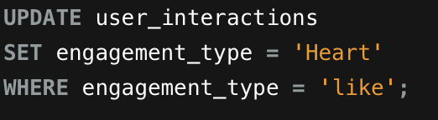
SQL Query –

Query Explanation - This specifies the table you want to update, which in this case is "User_Interactions." Now we need to set it as 'Heart' which is changed under SET engagement_type = ‘HEART’ which is previously was 'Like' where "Engagement_Type" is currently set to "Like" will be affected by the update.

